
Dear Parents,

We are happy to announce that a Therapy Dog will begin visiting your child’s classroom on a weekly basis from the University of Tennessee’s College of Veterinary Medicine. These dogs have been medically and behaviorally screened by the University’s HABIT program. HABIT provides therapy animals for many places in 19 counties in East Tennessee. These animals work in a variety of health related institutions and schools.

The dog assigned to our classroom will spend 5-10 minutes with your child sharing a book or just enjoying each other’s company. We are proud to be able to offer this activity to our students and know it will be both an emotional and educational experience. Please sign below stating that your child has no known allergies to dogs and return this page to your teacher.

My child, _________________________, has my permission to share some quiet time with UT College of Veterinary Medicine’s HABIT dog and has no known allergies to dogs.

___________________________ __________________
Parent’s Signature Date

Sincerely,

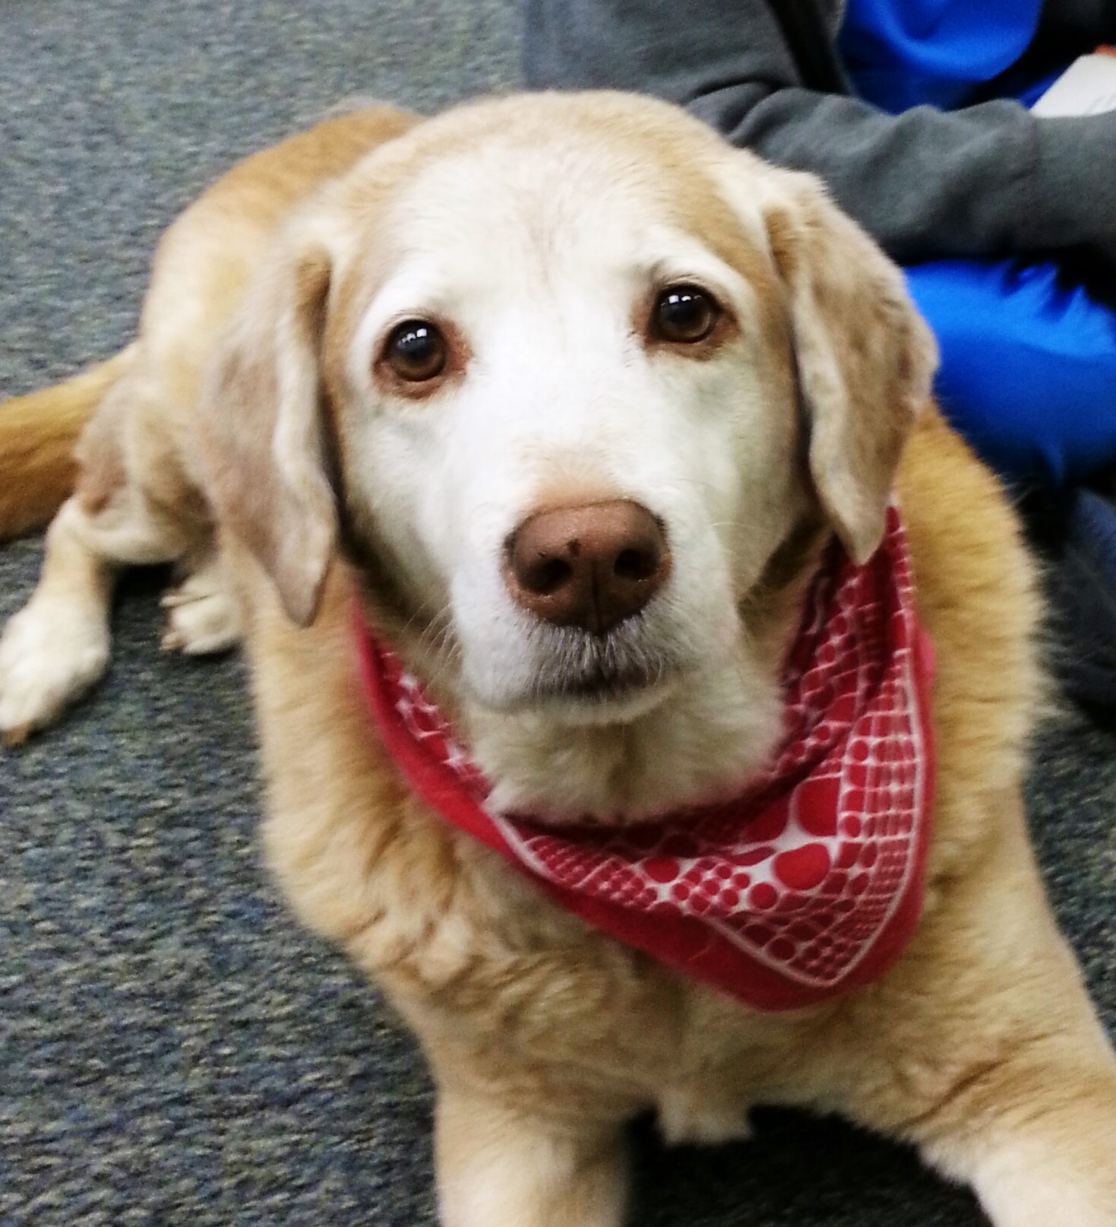 HABIT dog Chrissy

