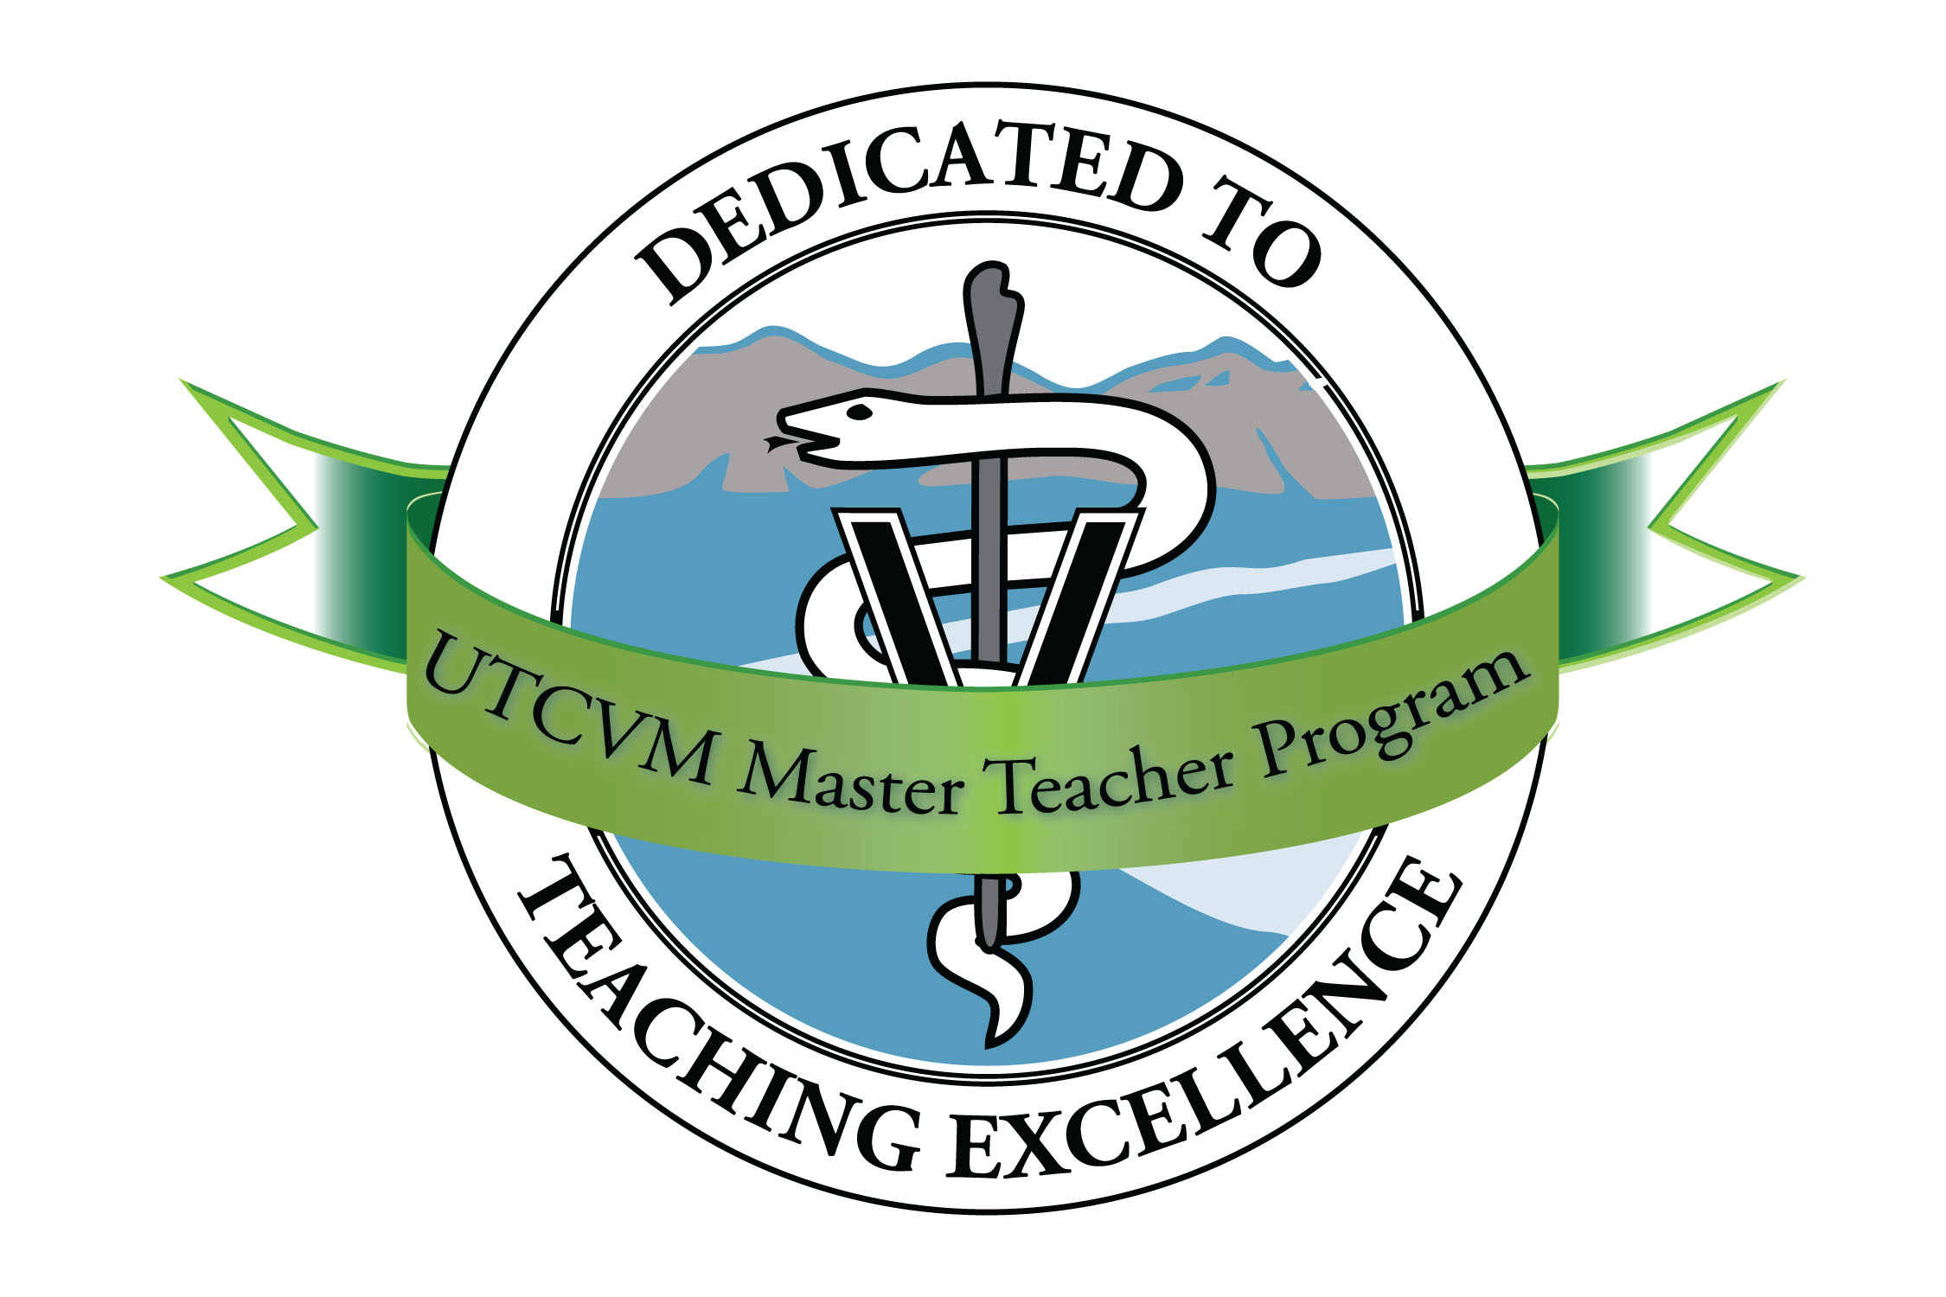
Master Teacher Program
University of Tennessee College of Veterinary Medicine

Fall 2014 Schedule

Thursday, September 18 8:00 -- 9:15 a.m. Sequoyah Room
Technicians as Teachers: Discussion with Veterinary Technicians and Assistants

Thursday, October 9 Note special time 12:00 -- 1:00 p.m. Sequoyah Room
<<Webinar>> Crossing the Synapse: Integrating Basic Science and Clinical Medicine at the Cognitive Level to Improve Medical Decision Making
Leslie Fall, Geisel School of Medicine at Dartmouth

Thursday, October 16 8:00 -- 9:15 a.m. Sequoyah Room
Integrating Basic Sciences into the Clinical Curriculum
Virginia R. Fajt, Veterinary Physiology and Pharmacology, Texas A&M
Mickey Sims

Thursday, November 20 8:00 -- 9:15 a.m. Sequoyah Room
Elements of Storytelling as a Pedagogical Tool
Rob Spirko, Department of English, UT

Plus, we’ll hear from our team attending the 2014 VEC Symposium!

FYI: Upcoming medical education meetings for late 2014:

Association of American Medical Colleges (AAMC); November 7-12, Chicago

