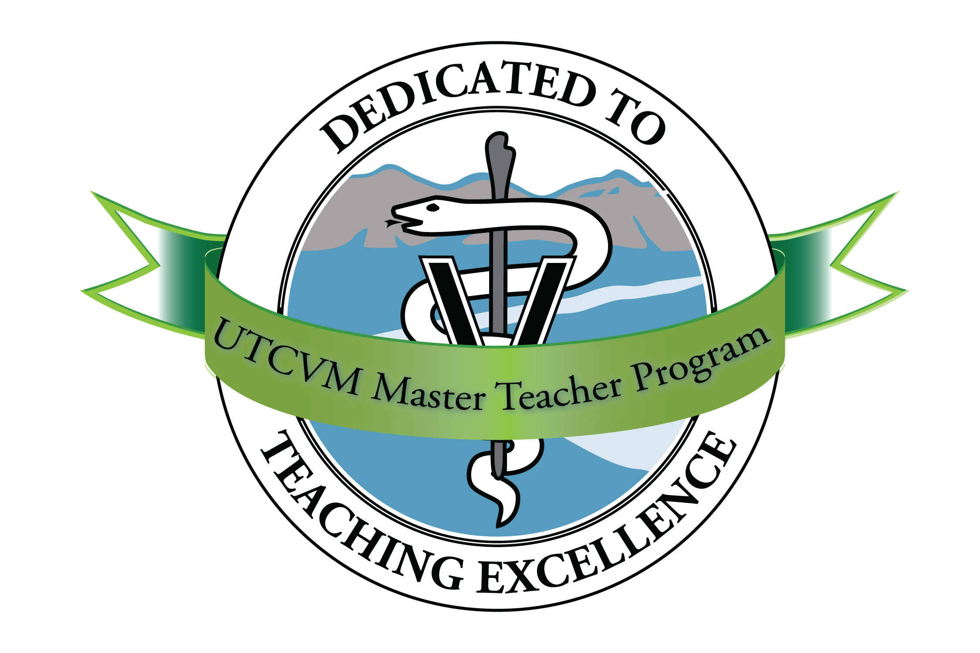
Master Teacher Program
University of Tennessee College of Veterinary Medicine
Spring 2015 Schedule

Friday, January 9 *Note special time* 9:00 a.m. -- 1:00 p.m. Sequoyah Room
Annual Fundamentals of Teaching Workshop
Update of the core topics for CVM instructors (principles of learning, objectives, lectures, and exams). While offered to meet the needs of new faculty, everyone is welcome to come for a refresher or update.

Thursday, January 15 8:00 -- 9:00 a.m. Sequoyah Room
Real Conversations about Grades
Courtney Wright, PhD, School of Communication Studies, UT
What are students thinking when they want to talk about a grade or test result? How can we make these conversations more productive and pleasant? Dr. Wright will share her research and communication framework, along with suggestions for instructors.

Thursday, February 19 8:00 -- 9:00 a.m. Sequoyah Room
Fair Use & Contemporary Copyright Law in Teaching
Frank Lancaster, Associate General Counsel, UT
India Lane, Assistant Vice President for Academic Affairs and Student Success, UT

Thursday, March 19 *Note location* 8:00 -- 9:00 a.m. Tickle Seminar Room
Analogics: Using Analogies and Metaphors in Teaching
José Castro
Mickey Sims

Thursday, April 16 8:00 -- 9:00 a.m. Sequoyah Room
Current Educational Policy Issues
Details to be announced

Thursday, May 21 8:00 -- 9:00 a.m. Sequoyah Room
Effective Graphics in Classroom Presentations
Joy Chambers, UTCVM Graphic Designer

FYI: Upcoming medical education meetings for 2015:
International Association of Medical Science Educators Annual Conference, June 13–16, San Diego
VetEd Symposium, July 9–10, Cambridge, UK
Association of Medical Educators in Europe, September 5–9, Glasgow, Scotland, UK

